**ANGLEŠČINA 5.b, sreda, 15. 4. in petek, 17. 4.**

**Obvestilo za starše in učence:**

Pozdravljeni učenci iz **5. b**!

Upam, da ste zdravi in vam šola na daljavo gre.

Potrebujem vaše elektronske naslove (oz. vaših staršev). V kolikor ste rešili samo interaktivne vaje na spletu, vašega elektronskega naslova nimam.

**Zato še ENKRAT:** Napišite mi kratko elektronsko sporočilo, da vas dodam na seznam stikov. Ta teden torej še ne bomo mogli izpeljati ure v živo.

V primeru kakršnih koli težav, nejasnosti ... sem dosegljiva na elektronski naslov:

[nbogataj@os-cerkno.si](mailto:nbogataj@os-cerkno.si)

Lep pozdrav,

učiteljica Nives

1. Najprej **rešitve** za nalogi: **(1. no; 2. no; 3. no; 4. yes)**

Slika, ki vsebuje besede besedilo

Opis je samodejno ustvarjen

(po vrsti od zgoraj: **1, 4, 2, 3)**

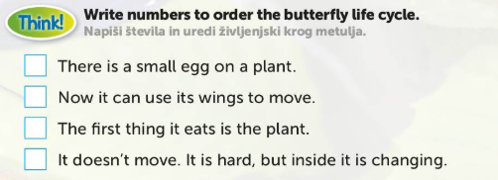

1. Pripravi si zvezek in ob zapiskih v zvezku na določeno temo si oglej **videoposnetke** na spodnjih povezavah – **ponovitev:**

<https://www.youtube.com/watch?v=SUt8q0EKbms> (deli telesa – lažja)

**ALI**

<https://www.youtube.com/watch?v=jkMtgLBtoFI> (deli telesa – težja)

<https://www.youtube.com/watch?v=hFIGwwE1uAM> (na tem so deli telesa, družina in občutki – vse skupaj, zelo lepo predstavljeno, je pa daljši, samo če želiš)

<https://www.youtube.com/watch?v=X6cAi0ydAyc> (meseci)

<https://www.youtube.com/watch?v=gMXFsO6PU-g> (vrstilni števniki – prvi, drugi, tretji …- ponovi)

<https://www.youtube.com/watch?v=Q67V1ZbQQQM> (svojilni zaimki – moj, tvoj …)

**Natisni in reši spodnje vaje:**

**REVISION EXERCISES**

**1. Dopolni z manjkajočimi deli telesa. (a leg, a foot, hair, a face, a mouth, an arm, an ear)**

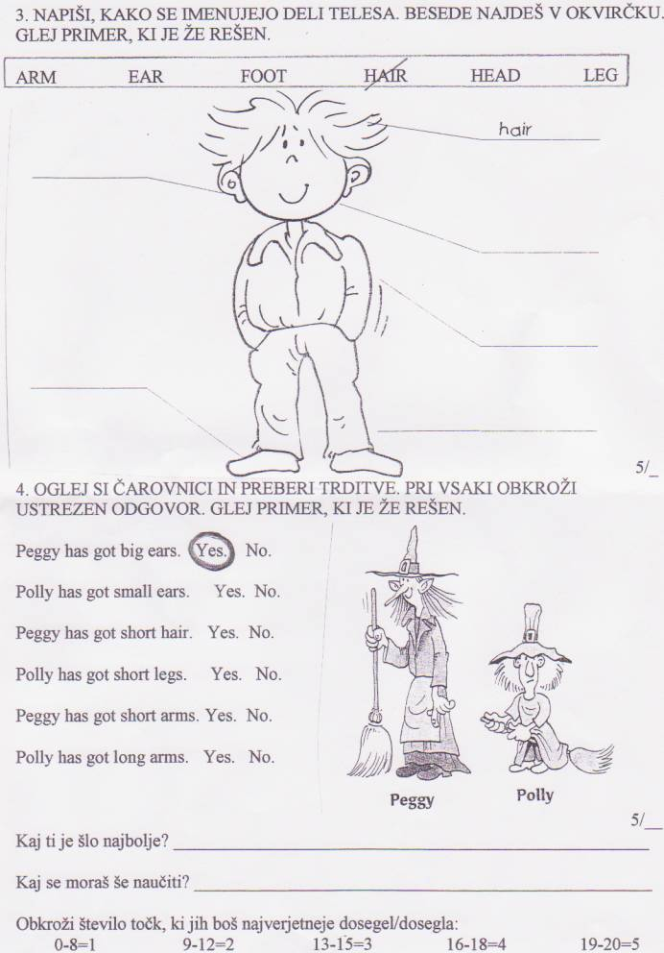

**2. Nariši svoj obraz in se opiši.**

|  |
| --- |
|  |

I’ve got……………………………. eyes.

I’ve got………………………….., ………………………………. hair.

I’ve got a……………………………… mouth.

I’ve got a……………………… nose.

My birthday is in…………………………………

My favourite month is ……………………………………..

**3. Dopolni manjkajoče mesece.**

January, F……………..………..…., March, A…………..…………….……, M…………………….….….., June, July, A…………………………………, September, O………………………………., N……………….………………………., D……………………………………

**4. Čarovnica Theresa se je opisala. Nariši jo po opisu. Sliko čarovnice nariši v zvezek in mi jo pošlji na elektronski naslov.**

My name is Theresa. I'm tall and thin. I've got long purple hair, one blue eye and one brown eye, big ears, a small purple nose and a big mouth. My cheeks are pink. I’ve got black glasses.

(tall – visok, thin -suh)

**5. Napiši besede za občutke pod ustrezne sličice.**

(happy, sad, excited, tired/ sleepy, hot, hungry, cold, angry, surprised, scared)

|  |  |  |  |  |
| --- | --- | --- | --- | --- |
|  |  |  |  | Frightened Smiley Face Emoticon' Poster by allovervintage | Emoji ... |
|  |  |  | Surprised Smiley Images, Stock Photos & Vectors | Shutterstock | Cheering Smiley | Emoticon, Smiley, Facebook emoticons |

(plonk: excited – navdušen, surprised - presenečen, scared – se boji/ prestrašen, hungry – lačen… ostale pa brez pomoči)

6. Reši interaktivni učni list: <https://www.liveworksheets.com/ud31689ym>

|  |
| --- |
| http://www.culinaryschools.org/clipart/eating/girl-eating.gif  **She** is drinking ……………… soup.  **[Royalty-Free (RF) Star Character Clipart Illustration by Toons4Biz - Stock Sample #17491](http://www.illustrationsof.com/royalty-free-rf-star-character-clipart-illustration-by-toons4biz-stock-sample-17491.jpg)1** |
| http://www.culinaryschools.org/clipart/eating/man-eating.gif  **He** is eating ……………… sandwich.  **[Royalty-Free (RF) Star Character Clipart Illustration by Toons4Biz - Stock Sample #17491](http://www.illustrationsof.com/royalty-free-rf-star-character-clipart-illustration-by-toons4biz-stock-sample-17491.jpg)2** |
| http://images.clipartof.com/small/215428-Royalty-Free-RF-Clipart-Illustration-Of-A-Large-Family-Eating-At-A-Reunion.jpg  **They** are eating …………… food.  **[Royalty-Free (RF) Star Character Clipart Illustration by Toons4Biz - Stock Sample #17491](http://www.illustrationsof.com/royalty-free-rf-star-character-clipart-illustration-by-toons4biz-stock-sample-17491.jpg)3** |
| [White Cat Drinking Clip Art](javascript:edit(14855))  It is drinking …………… milk.  **[Royalty-Free (RF) Star Character Clipart Illustration by Toons4Biz - Stock Sample #17491](http://www.illustrationsof.com/royalty-free-rf-star-character-clipart-illustration-by-toons4biz-stock-sample-17491.jpg)4** |
| http://www.picturesof.net/_images_300/Woman_In_Wheelchair_Eating_Dinner_Royalty_Free_Clipart_Picture_090113-214001-226009.jpg  I'm eating …………… food.  **5** |
| **http://2.bp.blogspot.com/-H-JAgqfOSDU/TWfxpF7hAaI/AAAAAAAAACw/EgSIhOTILVM/s1600/101471-Royalty-Free-RF-Clipart-Illustration-Of-A-Boy-And-Two-Girls-Eating-Ice-Cream-On-A-Bench.jpg**  We are eating …………………… ice-cream.  **6** |
| http://www.clipartoday.com/_thumbs/005/001/Food_and_Drink/Meals/Dinner/mother_son_104499_tnb.png  You must eat …………… food.  **7** |

**7. Preberi in dopolni z ustreznim svojilnim zaimkom:**

my – your – his – her – our – their – its