7. razred, preverjanje 3
- Put the verbs in the Present Simple Tense. Postavi glagole v sedanjik Present Simple.

Hi! I'm Jenny. I'm a famous writer. Just kidding! But I really WANT__(want) to become a writer one day.
I ______________ (love) reading detective stories and horror stories. My parents __________________ (not believe) I can become a writer one day. My mother _________________ (think) that it ________________ (not be) a real job and my father ____________________ (say) that writing _________________ (not bring) a lot of money. But I _________________ (not agree) with them. I_________________ (know) that there are a lot of writers who are rich.

- Put the verbs in the Present Continuous Tense. Postavi glagole v sedanjik Present Continuous.

We _ARE DOING___ (do) English exercises right now.
We ______________________ (prepare) for the test.
We ______________________ (not have) History at the moment.
______________ Henry ______________ (write) in his notebook?
I ________________________ (look) through the window.
Why _____________ Lara ________________ (stand) at the bus station?
______________ she _________________ (wait) for someone?

- Complete the text. Use the Present Continuous or the Present SimpleTense. Vstavi ustrezen sedanjik – Present Simple ali Present Continuous.

- Peter and Mary __________________ (live) in Bristol. Peter ___________________ (work) in a car factory and Mary __________________ (be) a doctor. At the moment they____________________ (not work).
- They _________________ (travel) on holiday. They ___________________ (drive) to Southport. They _________________ (go) thereevery summer.

b) My name _________________ (be) Yoko. I _________________ (come) from Japan. My parents and I __________________(live) in Tokyo. My mother_________________ (be) a secretary but she __________________ (not work) at the moment.She _______________ (take) care of my little sister who is only three months old.I ____________________ (love) my sister, but I ___________________ (not like) her crying. Oh no! She _____________________ (cry) again!

- Put the sentences into the Past Simple Tense. Postavi povedi v preteklik Past Simple. Glej primer.

PRESENT SIMPLE | PAST SIMPLE
I swim I swim at our local swimming pool very often. | I swam at our local swimming pool very often.
There are many shops in our town.
We We can go to France by train.
I do I don't visit my best friend every day.
They see their mum through the window.
I don't eat pizza very often.
We can't come to the party.
- Put the verbs in brackets into the Past Continuous Tense. Postavi glagole v oklepajih v preteklik Past Continuous. Glej primer.

Last Friday my sister and I had a party at our house. We had the house all to ourselves because our parents were staying (stay) with grandma for the weekend. While they _____________________(enjoy) their weekend in the country, we ___________________ (have) a great time with our friends. I _____________still_____________ (get) the food ready when the first guests arrived. Toby was the DJ. He ______________________ (play) music all evening .Tina ___________________ (make) fruit cocktails. They were delicious. While we ___________________ (dance) someone knocked on the door. It was our neighbours. We _____________________ (make) too much noise. I apologized and they said it was all right as long as we were a bit quieter.

- Put the verbs in brackets into Past Simple or Past Continuous. Postavi glagole v Past Simple ali Past Continuous.

Last Saturday I ________________ (wait) for my parents to come home in the evening .It _______________ (be) late.I _________________ (sit) in front of TV and ________________ (eat) dinner when suddenly the bell _________________ (ring). I ______________ (be) scared because I __________________ (watch) a horror movie. I __________________ (go) to the door. A dark figure ____________________ (stand) outside. I ______________ (run) back into the living room and _________________ (call) Mum and dad. While I ________________ (dial), somebody suddenly ________________ (knock) on the window. It __________________ (be) my grandma who came to check if I was ok.

- Vocabulary. Label the pictures. Kaj vidiš na sliki? Poimenuj.

- Complete the sentences with the names of places or shops in a town. Dopolni.
- Connect the words from the box with their Slovene translations. Poveži z ustreznimi prevodi.
hut childhood Stone Age hunter gorge medieval gate crossroads
English | Slovene |  | English | Slovene
 | kamenadoba |  |  | lovec
 | koča |  |  | vrata
 | križišče |  |  | srednjeveški
 | otroštvo |  |  | soteska

- Fill in the words from the box so that you get meaningful sentences. Smiselno dopolni z besedami iz okvirja.

matches sunscreen judge haunts guide prison fields notice board

We went down the Soča River on a raft with a local ______________________.
Many years ago the Tower of London was a __________________________.
We use a lighter or ______________________ to make fire.
Farmers have large______________________ where they grow food.
People say that the ghost of Anne Boleyn still _______________________ the Tower of London.
‘I didn’t kill him!’ said Billy, but the __________________ didn’t want to listen.
You should always put on ______________________ when you spend a lot of time in the Sun.
Last week I put a message on the____________________________ at school.

- Asking the way. Complete the dialogue with the expressions from the box. Dopolni z besedami iz okvirja.
roundabout right go along go straight on are there welcome past
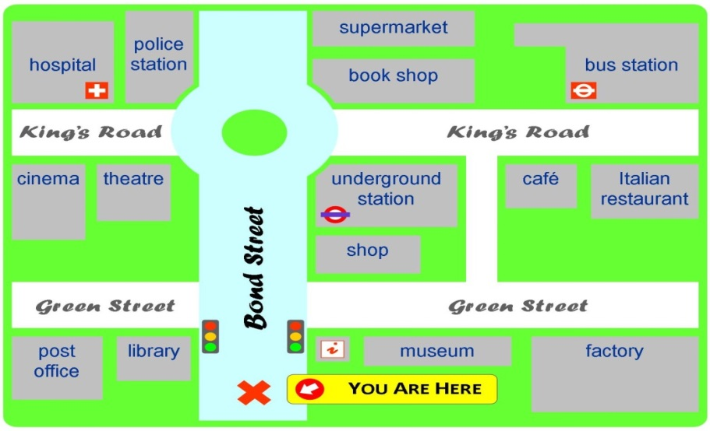
TOURIST:Excuse me, ____________________any good restaurants around here?
WOMAN:Yes, I know a very good Italian restaurant and it is not far from here.___________________ Bond Street. At the traffic lights ___________________ until you come to a ___________________. Take the second exit at the roundabout. Go along King's road ,______________________ the underground station and a café. The restaurant is on your ___________________, next to the café.

TOURIST:Thank you very much!

WOMAN:You're____________________!

- Writing.Which of the following inventions is the most important for you? A mobile phone, television, CD player X-box or computer? Katera od zgoraj omenjenih naprav je zate najpomembnejša?
Why? Write 50 to 60 words. Give at least two reasons for your choice and write three things that you can do with this invention. Zakaj? Napiši vsaj dva razloga
Napiši tri stvari, ki jih lahko počneš s pomočjo te naprave.
_________________________________________________________________________________________________________________________________________________________________________________________________________________________________________________________________________________________________________________________________________________________________________________________________________________________________________________________________________________________________________________________________________________________________________________________________________________________________________________
- Read the text and decide whether the statements below are true, false or it doesn't say in the text.

Tom Barker was born thirty years ago in a small village on the south coast of England, but when he was ten years old his family moved to London because Tom's father got a good job in a bank. Last week Tom went back to the village where he spent the first ten years of his life. This is what he told us when we interviewed him:
»I could remember the village very well. When I was a child, there was a small village shop where you could buy everything you wanted. They sold fantastic sweets and cakes and fresh bread. I went to the village school for five years. There were only thirty pupils in the school so the classes were very small. At weekends, we took our bikes and went to the beach. We didn't stay at home very often because we didn't have a television in those days, but when the weather was cold I often spent time at my friend's houses. Everybody in the village was very friendly.
But now, everything is different. When I came back last week, I couldn't find our house. There isn't a village shop or a post office. Now there's a large supermarket and people go shopping there. There are new houses everywhere but the village school is closed. All the children go to school in the town a few miles away.
I was very sad because the village isn't the way I remembered it. My old friends weren't there and the new people weren't very friendly.«
T/F/DS
- Tom was born in a small village in Scotland.
- Tom's father worked in a bank.
- Tom went back to the village last year.
- There was a chemist's in the village.
- The village shop sold bread.
- Tom's sister went to the village school.
- Tom had a bike when he lived in the village.
- Tom visited his old house.
- There's a big car park at the supermarket.
- Children don't go to school in the village now.
- Tom was very happy when he went to the village.

