REŠITVE PREVERJANJA

**Naloga 1** (kot si sledijo okvirčki na sliki)

police station restaurant hotel park

bus station cafe post office

**Naloga 2**

BEHIND/OPPOSITE

BETWEEN

IN FRONT OF

NEXT TO

NEXT TO

OPPOSITE/IN FRONT OF

IN FRONT OF/NEXT TO

IN FRONT OF/NEXT TO

**Naloga 3**

1. THERE ARE 6. THERE IS

2. THERE IS 7. THERE ARE

3. THERE IS 8. THERE IS

4. THERE ARE 9. THERE IS

5. THERE IS 10. THERE ARE

**Naloga 4**

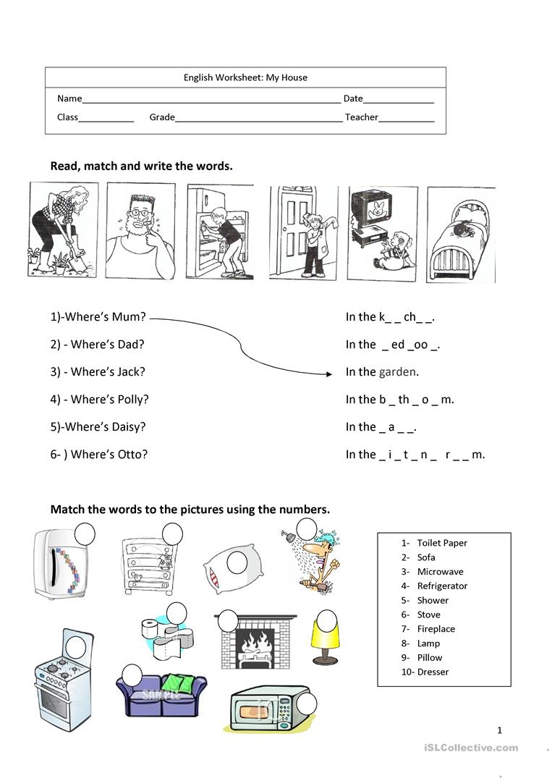

Pravilno črkovane besede po vrsti: KITCHEN, BEDROOM, BATHROOM, HALL, SITTING ROOM

**Naloga 5:**

1. ON
2. UNDER
3. BEHIND/ NEXT TO
4. ON
5. ON
6. IN
7. BETWEEN

**Naloga 6: (v vrstnem redu kot so postavljene sličice)**

**4 10 9 5**

**1 7 8**

**6 2 3**

**Naloga 7:**

EAR ARM EYES FINGERS

MOUTH CHIN (FACE) NOSE LEG

**Naloga 8:**

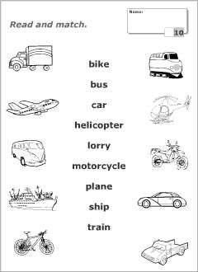

**Naloga 9:**

Odgovori: A, B, A

**Naloga 10:** (vstavljene besede v pravilnem vrstnem redu)

come starts house dog food volleyball